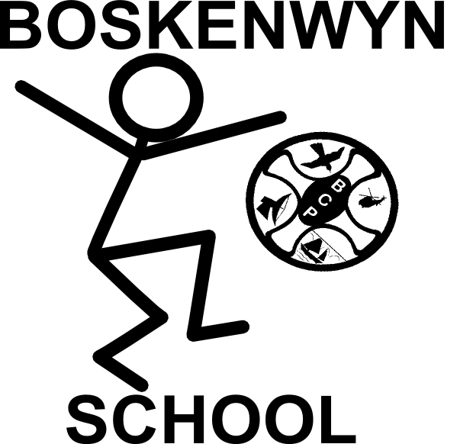
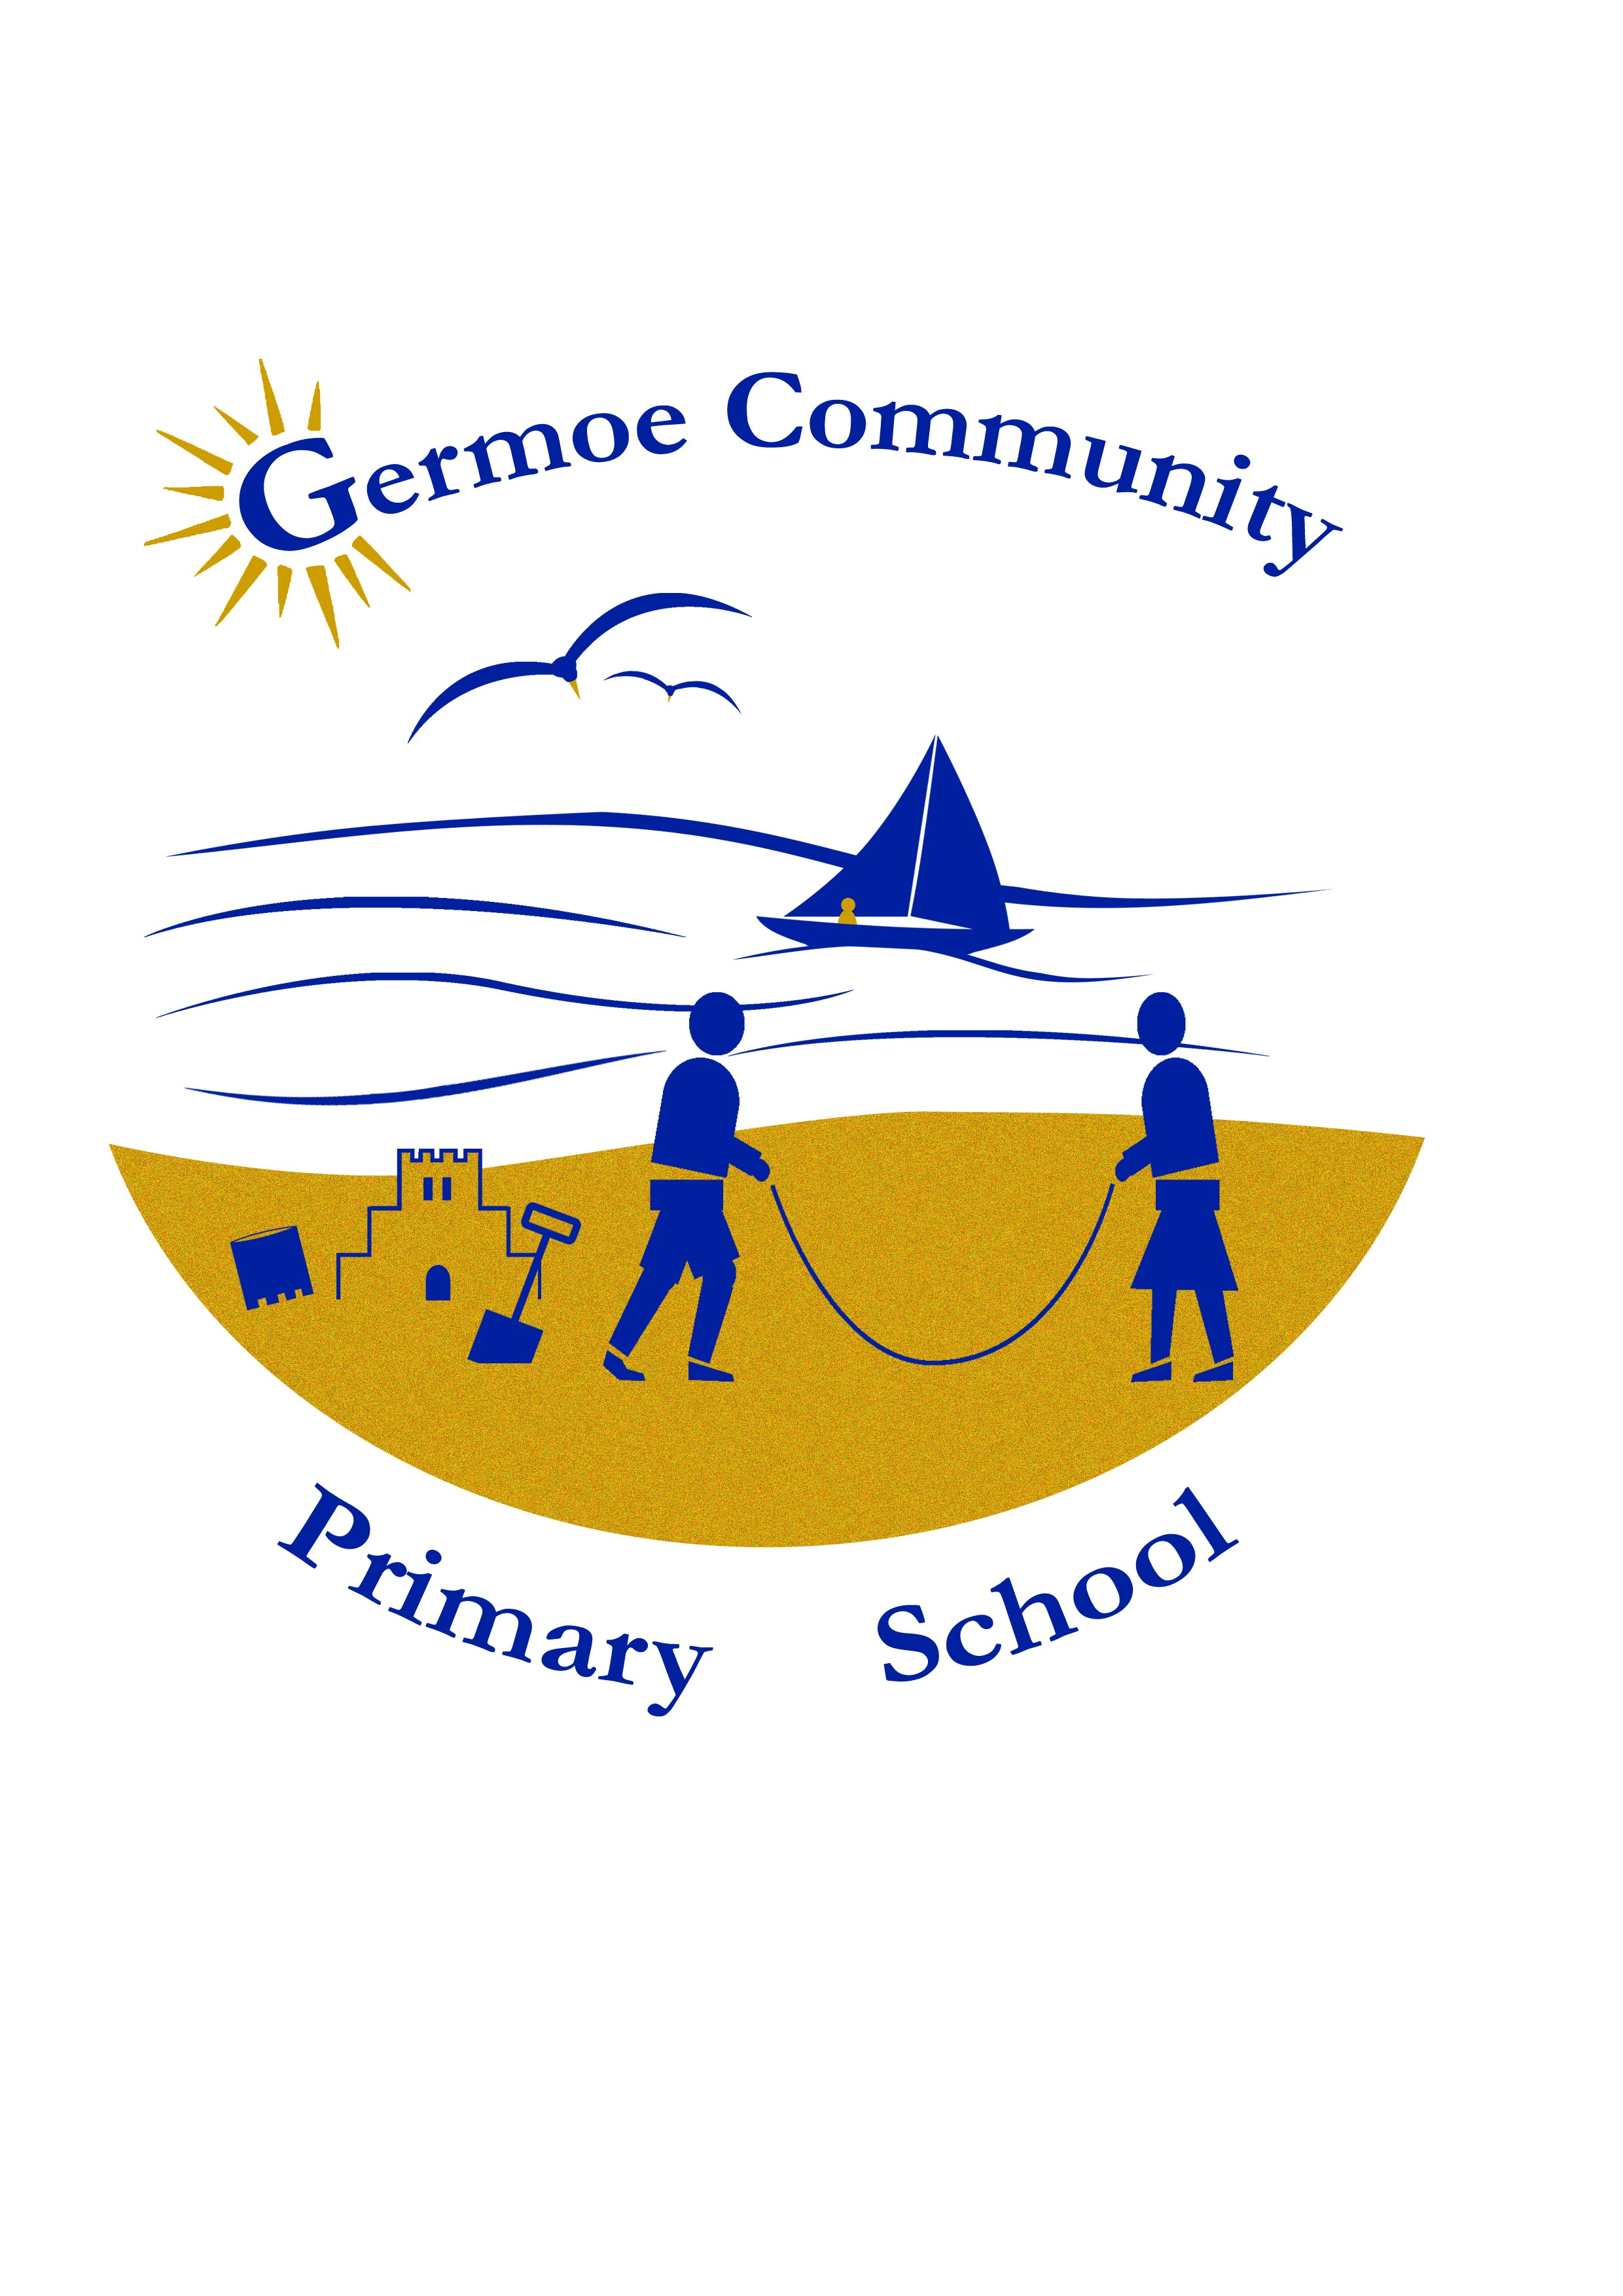

The Federation of Boskenwyn & Germoe Schools

REGGIO EMILIA INSPIRED / ENQUIRY BASED LEARNING – PROGRESS REPORT
P. QUINNEY NOVEMBER 2016

Background. One of school priorities for improvement is to embed the Reggio Emilia inspired approach to learning into our early years and beyond. This approach teamed with the enquiry based learning used by many international schools will help us to help children to focus and build upon their innate confidence resilience, creativity, independence and much more….. The skills they can carry with them throughout their lives; to tackle problems and work with products that don’t even exist yet. A recent study by Oxford University found that as technology races ahead; our future work force (particularly low-skilled) are at risk of being computerised out of their jobs. A whopping 47% of current jobs are at risk so for our future workers to win the employment race they will have to increase their creative and social skills. By fostering fun, play and creatively in the classroom and beyond, the Reggio Emilia and Enquiry based approach nurtures these skills and instils critical thinking, collaboration, imagination, agility and more. Only a handful of settings across the UK practice the Reggio approach so in order to be ahead of the game we are prepared to travel far and wide to ensure we are getting the best for our children, so Worthing it was.

Our journey so far…
We are only in the infancy of our journey and realise we have a long way to go to fully embed Reggio Emilia and Enquiry based learning but already we have seen great results. Our INSET days in Norway, Denmark and Reggio Emilia, Italy itself have helped us to develop as teachers and implement strategies to develop our children as learners. With the restraints of our National Curriculum and testing of Y1 Phonics and Key Stage 1 and 2 reading, writing and maths, it is difficult to take away one or two approaches and simply plant them into your own soil; we have had to figure out what aspects are most important to us and what kind of soil we need to make those aspects grow. Our children have played a huge part in helping our system to develop; their feedback has shaped our practice, shaping our own future gives us all a sense of ownership and therefore a much greater chances of success. Our recent test results are indicators of the positive impact our approach has had so far on academic progress and attainment. Behavioural incidents have lessened and there is little if any low level disruption in classes due to all children being on task. Attendance figures have increased compared to the year before and our pupil questionnaires show that all children enjoy coming to school and enjoy learning.

Professional Development Day
Reflections Nursery, Worthing, Sussex – Saturday 12th November 2016 (P Quinney, J Burns, D Rusga, S Prescott, B Reeves, A Larcombe, L Jones)
Yes, a Saturday! Last weekend, we travelled to Worthing to further develop our knowledge and skills of the Reggio Approach; it’s rare for a course to be held in the UK so we jumped at the chance. We had a great weekend; A long drive on Friday but it gave us time to plan and relax, a wonderful Thai meal in Worthing Seafront and a comfortable bed ready for an 08.30 start. Reflections Nursery were celebrating 10 years of using the Reggio Approach and shared their journey using slides, discussions and tours. Wow! What a valuable insight it gave us. One of the memorable moments was when we shared a thinking journey with a class of 3-5yr olds as they travelled from Bacteria to Galaxies. We gained so much from this experience which in turn means our children will have gained so much from our experience. Rather than comment about what we learnt, I will share with you what we have taken away from the development day and intend to develop within our Federation. Each staff member wrote 3 things they were taking away from the training and all were very similar. These were:-

- The importance of the environment as the 3rd teacher
- perspectives/provocation , projection – light dark
- Immersion (depth rather than breadth)
- Encourage creativity – 100 languages
- Documentation
- Quality of interaction – displays
- Recording of work

- The environment as the 3rd teacher
The quality of the environment plays an active role in how children play and learn. Building, organisations, resources; all are so important in developing learning that it can be seen as having a 3rd teacher in the room. Welcoming, tidy, practical, calm with open ended resources to encourage curiosity, creativity and communication (Tablecloths, vases, flowers). Every space has a purpose both indoors and out. Spaces where children can be creative, make choices explore and investigate, think and reflect, communicate and be challenged. Spaces have features such as visibility (light, airy) flexibility (moveable furniture/resources), light (OHP/Light tables/dimmer switches drawing children to look closer) and shadow, reflection (mirrors, infinity boxes to promote self awareness and self discovery, curiosity, investigation, seeing things from different perspectives), multi-sensory (variety of textures, colour, sound, smell (plants, potpourri) – neutral colours to allow displays and resources to stand out better.

Questions for us to consider
- Does every space have a purpose?
Are there some spaces we would like to improve?
- Do we make enough use of light, shadow and reflection?
- How flexible and sensory are our spaces?

2) Immersion
A new approach named “Immersive Learning” is doing its round at present around Cornwall and the rest of the UK. We have discussed it as a staff but are not keen. It is all about turning your classroom every term into a space linked to your topic eg titanic, classroom turns into a ship. We thought it would discourage curiosity/imagination go against what we are striving to achieve, children might be afraid of/disinterested in the theme and it would have a negative impact on social, emotional and academic progress.
Immersion in Reggio/Enquiry terms is more about depth rather than breadth with open ended resources, spending more time to investigate and explore, looking at things from different angles and perspectives with different tools and media, light and shadows, children using their hundred languages on a child led long term project instead of reading/writing alone. The focus is on the learning journey rather than the outcome. When children are immersed and have the opportunity to play with their ideas in different situations and with a variety of resources they discover new connections and come to a new and better understanding and ways of doing things. With adult support, this process enhances ability to think critically, ask questions, creativity emerges as they become absorbed in exploring and investigating. This leads to mastery of the area which they are learning about and the skills they are using.

Questions for us to consider
- Do we give children enough uninterrupted time to be deeply immersed in their learning?
- Are our routines flexible enough to allow children to follow their interests?
- Do we spend enough time consolidating learning and reflection?

3) Documentation
The quality of how we document children’s learning is very important in the Reggio Inspired setting. Traditionally we have tended to display and assess the end product not the learning process. Schools /nurseries are increasingly documenting the learning process (acquiring knowledge, organising and processing it, researching, adult intervention etc) as this, the learning journey, is more important than the finished product. Documentation and recording observations of how children think and displaying these remind children, staff and parents of the learning process and the conversations and discussions which helped them.

Questions for us to consider
- How well do we document and display the learning process?
- Does our documentation record the quality of interaction?
- How well do we share the learning process with parents?

Next steps:
All of the questions above will be discussed in a staff meeting, shared with the whole of the staff and implemented into our school development plan.

Further training for staff on the Enquiry Based Curriculum and Reggio Inspired settings will be provided during the INSET days 5th & 6th June 2017 in Amsterdam and International Schools and Kindergartens.

