The Federation of Boskenwyn and Germoe Schools  Visit to Tromsø, Norway 2016 | 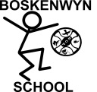  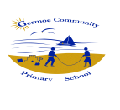
Once again our Governing board have supported the growth of our schools by enabling staff members to observe other educational practice beyond our shores. Our group comprised of staff from Boskenwyn, Germoe, Garras and Sithney Schools and we welcomed our Educational Psychologist, Sue Leathley and Vice Chair of governors, Sandy Easterbrook to share this experience with us. We visited Tromsø, in Northern Norway.

Our purpose was to explore four areas;
1. To explore what enables pupils to learn outside so successfully when it is -20 and, during the winter months, completely dark at all times.
2. To learn more about the 'Inquiry Based' approach to learning in International schools
3. To understand the LøFT approach to learning behaviours
4. To further investigate the Reggio Emilia inspired settings

Why Norway?
With our approach to learning already focused on the growth mindset and adopting a “can do” attitude to learning, we wanted to investigate how we could build our learning power even more by observing children’s resilience in an extreme setting. The Scandinavian countries have a proven track record of being high achieving, independent, healthy, widely travelled citizens with an excellent command of at least one other language than their mother tongue. Hence, Tromsø; remote, cold, dark, Scandinavian and successful!

So what did we discover?
In order to really grasp the context it would be helpful to describe Tromsø. This Northern most city in the world is situated amongst the fjords on a series of islands surrounded by huge snow-capped mountains. The air is remarkably fresh, no sign of pollution and life seems tranquil. In the winter months there is little or no daylight. When the sun returns, for just two minutes on the first day, there is huge celebration. For several months, the area is covered in snow and people have to dress appropriately to keep warm. Life goes on as normal, vehicles drive on iced up roads, the infrastructure is not hampered by the cold and schools do not close. Pupils often ski to school. Snow is a great muffler of noise and a sense of calm prevailed everywhere. Life is a little slower and calmer, people take their time and appear stress free.

1. To explore why pupils learn outside so successfully when it is -20 and during the winter months, completely dark at all times.
It quickly became apparent to us that the force of nature rules this land. As a result, respect for nature is immense. It is a way of life to them and it positively nurtures well-being. In school, working and playing outdoors is constant and staff in the schools we visited reported less child illness. Quite often at home we think cold and rainy means potential illness.
Learning takes place, even in the dark. One school we visited had a plot of land by the fjord edge where children played all day, retreating into tepees with log fires to nap. They used sleeping bags or reindeer skins for warmth and laid on raised platforms. They were lulled to sleep by the ripples of the fjord. Children ate cold lunches, generally comprising bread, cheese and meat. Outside there was little in the way of resources and children played imaginatively with each other, exploring and thinking. We have been so right to offer Forest School experiences as these mirror what we saw.
We were reminded about our culture's over-anxiety about risk assessments, safety and decision making by pupils. We realised how much further into our journey to promote skills for life we are now than when we visited Copenhagen in 2014.
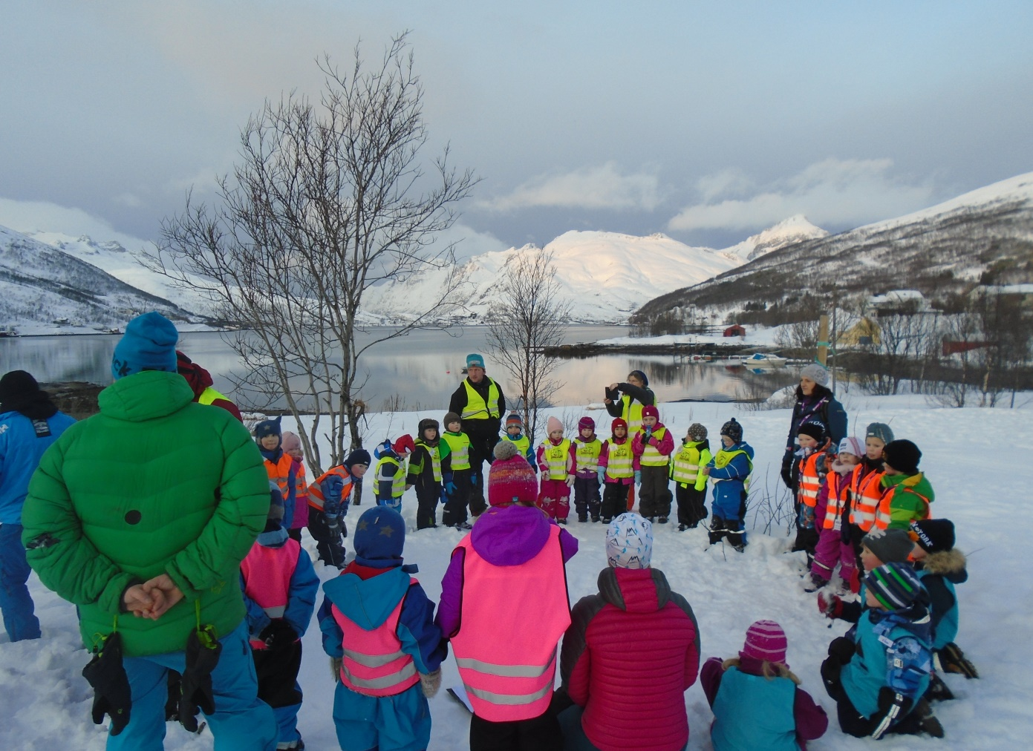

Action:
Emphasise importance of children being dressed appropriately to work outdoors.
Overcome the concept that being in the cold makes you ill. There is no such thing
bad weather, just bad clothing.
Mrs Rusga, our Forest School teacher, to offer further opportunities for parents to
explore what it all means.

2. To learn more about the 'Inquiry Based' approach to learning in International Schools
Tromsø school accommodates children from all over the world. Their parents come to Tromsø associated with career moves and mobility is high. The staff are qualified teachers with a thirst for travel and also come from all corners of the globe. They follow the International Primary curriculum so when they move to another school elsewhere in the world the transition is seamless. Older pupils follow the International Baccalaureate programme.
Class sizes were very small, never more than 15 pupils in one class. We witnessed lots of inquiry based learning, one of the most powerful we saw was in the Yr3/4 class where pupils were investigating machines. The whole approach was inquiry led, pupils asking questions, thinking, evaluating and establishing their own next steps. The culture for working collaboratively was well established and this made the experience even more meaningful. This is the approach we are working towards in our schools and it was wonderful to see the end product; the enthusiasm of the children on their learning journeys, taking control of their own learning with the scaffolded support of the classteacher, reaching their own conclusions and using skills for life such as resilience, independence, teamwork, risk-taking, reasoning, problem-solving. Another outstanding lesson we observed was Y5/6 maths. Children using similar skills when learning about algebra, using the four step method we have recently introduced which leads to mastery; new learning/revisiting, practice and refinement, problem-solving/challenge, real life context. Children were using their growth mindset to help them find solutions, they were persevering and being resourceful and resilient.

These are skills needed to successfully access the new curriculum, particularly in maths, learning must be approached in a more problem solving way, linking to real life contexts. Having seen its’ success in action, we will continue to embed the 'Inquiry Based' approach, Miss Symons is leading the implementation in maths at Germoe and Mrs Nicholas at Boskenwyn. You are very welcome to come in and observe in action. As a whole staff, all subject leaders will come together to plan an inquiry based approach to the next topic.
.
Action:
To further research the 'Inquiry Based' approach and associated training.
To consider how we can embed this approach into the whole curriculum.
To engage all staff, pupils and parents in this process.
To continue to use this approach in the development of maths learning in school.

3. To understand the LøFT approach to learning behaviours
We learned about the 'Loft' philosophy; an approach which focuses on how to improve rather than dwell on and analyse the cause of a problem. Children were encouraged to think in this way during work and play but staff also used this as a philosophy for their pedagogy. We could see the benefits of the 'onward and upward' approach but we felt that some reflection on why something didn't work can be valuable too. We will continue to focusing on the positive behaviours, those we would to see and try to embed this more in the classrooms with behaviour for learning, enhancing the growth mindset and can do attitude. We will focus on how children succeeded, the methods and skills they used and share them with the class.

Action:
To focus on the positive behaviours for learning and share them.

4. To further investigate the Reggio Emilia inspired settings
Two of the settings, we visited were Reggio Inspired. This meant that they focus on providing an exciting context for learning with the a variety tools for them to learn in a a variety of ways. The Reggio principle of “Children learn in over a hundred ways so why limit them to reading and writing” was apparent in all of the settings, not just the Reggio inspired. Children used their imagination and creative thinking skills. Natural resources, such as a block of wood, were allsorts from shelters to animals! Snow was a source of food, water, shelter, slide, seat, text book, plasticine and more! We were satisfied that what we had introduced after Copenhagen was similar and is working well and we will continue to use these methods in the early years.

Action:
To explore ways of embedding Reggio principles into key stage two

On a final note, we met the most inspirational people. We chatted with a kindergarten leader who started her school in 1980 and has grown it ever since. She had so much wealth of knowledge, common sense and passion for her work. It moved us to hear her journey and made us reflect on how the little things we do influence lives as much as the big things.
We also met an experienced Special Needs teacher who spoke with compassion about each child's journey. It reminded us of how individualised these children's journeys are and how rewarding it is to make a difference when you fit the curriculum around the child and not the child around the curriculum.

We concluded our journey with this thought...
Tell me and I’ll forget,
Show me and I may remember,
Involve me and I’ll understand.

Our children need to involved in their learning journeys. Different types of learners need to be celebrated for their uniqueness not measured on purely academic progress through testing. We will discuss all of the methods and approaches at our next parent/governor meetings. We would really like to hear your views and opinions and for you as parents/carers to be as involved as us and your children in our journey to acquiring life-long skills and a” love of learning for life.”

P Quinney – Executive Headteacher
L Jones – Key stage 1 teacher, Sport Lead professional
S Prescott – Key stage 1 teacher, Head of Early Years
D Rusga- Nursery/reception teacher, Forest School teacher

3rd February 2016

