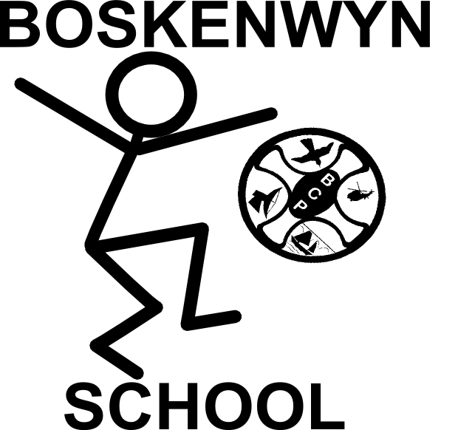


The Federation of Boskenwyn & Germoe Schools

Parent governor meeting Boskenwyn – 17.9.18

17th September 2018

Present: P Blackburn - Executive Headteacher, R Monhemius – Chair of governors, Mr Zhang Tian, Chinese Language assistant, parents of Boskenwyn School
Parking
Parents suggested a drop off zone to ease congestion. Minibus parking was discussed but no resolution found as yet. We will continue to look into this.
Collaborative working
PB informed parents of the extension of our collaborative working with Marlborough Primary school and the benefits to all involved. PB will be working alongside the substantive head on Fridays for the rest of this term until his retirement – see letter to parents for further information and developments.
Chinese Language Assistant
PB introduced parents to Mr Zhang and explained the purpose of his post. His long term living arrangements were discussed.
Playground
Parents asked about rough play zone. PB to speak to children about what they want and decide how to take it forward. Chill out zones were discussed and the possibility of a tree house. Playground buddies discussed.
INSET
Possible parent rota for childcare during INSET in May/June was discussed. PB explained staff visits to Iceland and Italy for training funded by European union, Erasmus scheme.
Uniform
PB explained why the uniform had not arrived. Parents asked if was ok to continue wearing the high street blue uniform and PB confirmed it was.
Meeting closed 1630

