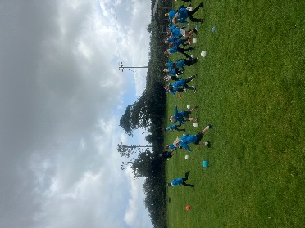

**Purpose of study**

A high-quality physical education curriculum inspires all pupils to succeed and excel in

competitive sport and other physically demanding activities. It should provide opportunities

for pupils to become physically confident in a way which supports their health and fitness.

Opportunities to compete in sport and other activities build character and help to embed

values such as fairness and respect.

**Aims**

*The national curriculum for physical education aims to ensure that all pupils:*

* develop competence to excel in a broad range of physical activities
* are physically active for sustained periods of time
* engage in competitive sports and activities
* lead healthy, active lives.

**Attainment targets**

By the end of each key stage, pupils are expected to know, apply and understand the

matters, skills and processes specified in the relevant programme of study.

**Intent**

We aim to develop our children’s physical development with diverse, engaging and practical P.E. teaching. Our exciting curriculum focuses on the progression of core skills in a variety of indoor and outdoor P.E. sessions, while introducing our pupils to a variety of different sports including dance, gymnastics and swimming in kS2.

At the centre of our curriculum is a focus on the development of core skills that are applicable in a variety of different sports. A core skill-set allows the students to confidently access the different sports that the school provides in lessons, in clubs and in teams. This begins in reception with basic ball and catching skills all the way to Y6 where students are focusing on the core skills of football, swimming and gymnastics amongst others. Furthermore, the curriculum is seasonally organized on a two year rolling programme to reflect the weather and sporting calendar to capitalise on interest in certain sports. We plan our lessons half-termly with a focus on a different sport with the aim of slowly building the basic skills at the beginning to ending with a competitive game situation for the children to test their newly learnt skills. Over a half term, children will have the opportunity to be taught two different sports. Each class and year group will complete the same sports/activities each half-term and the same each year. This way, children can show progression within their sport from the year before by being challenged and given new opportunities and objectives to complete.

We will continue to provide our pupils with opportunities to become physically confident by developing their physical health, competitive nature and love for sports.

These ambitions have been greatly enhanced by the sessions run by external sports professionals. This includes a surf club ‘Global boarders’ which gave children the chance to try something different and unique away from the curriculum. We are also part of the Helston cluster of Primary schools which gives us the chance to compete in different sporting events as teams and individuals. We have pupil-nominated sport leaders who support with break time games, looking after our equipment and taking warm ups in P.E lessons.

**Implementation**

Our curriculum is focused on having trust in teachers planning and delivering of lessons. Across our school, specifically, Early Years and KS1 focus on core skills such as effective movement, throwing, catching and balancing. These are introduced via different games and play based scenarios building up to some team based activities by the end of Y2.

Children are assessed through lessons and how far they need to be moved on with whatever sport they may be learning. Children are split into differentiated groups to make sure all children have the chance to progress even though they may be at different levels.

In KS2, these core skills are utilised in indoor and outdoor P.E. lessons with the introduction of invasion games, striking and batting games, gymnastics and athletics.

Furthermore, our sports, cross country, sailing and surfing club give those children a chance to attend a club they might not have had the chance to take part in before.

**Impact**

* According to pupil voice surveys, most pupils strongly agree that P.E. is well taught and resourced. Furthermore, most students believe that there is a wide range of sports on offer in lessons and clubs.
* Children are given the chance to experience a wide range of different sports whether this may be team games, individual, dance, gymnastics, athletics or water sports throughout their time at Boskenwyn School and Germoe School.
* From our surveys with pupils and in accordance with our own priorities for this academic year, empowering children to engage in inter-school competitions is a significant aim of our provision and is becoming an increasingly regular feature for our sports clubs.
* Children are given the chance to compete against other local schools in a variety of different sports.

**Pupil Voice:**

Year 5 pupil: I love doing PE because we get to try out lots of different sports.

Year 3 pupil: I like playing basketball the most in PE because it challenges me.

**An Example Progression of Skills**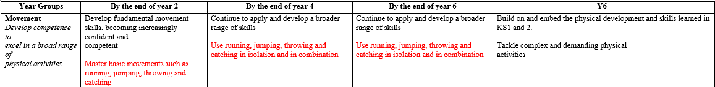

**Examples of Learning Outcomes**

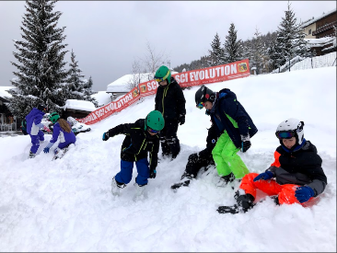 Our school ski trip.

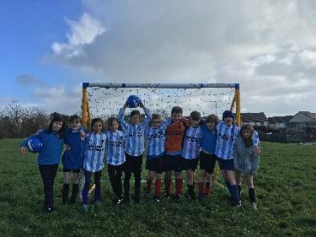 Children competing in a football tournament against other schools.

**Cultural Capital**

Cultural capital is about preparing pupils with the essential knowledge and skills for what comes next. The exploration of new skills and experiences helps to nurture resilience, curiosity, and creativity. Through this journey pupils develop new forms of cultural capital that makes a difference in individual mind-sets, which consequently shapes their future.

Cultural capital is the accumulation of knowledge, behaviours, and skills that a child can draw upon and which demonstrates their cultural awareness, knowledge and competence; it is one of the key ingredients a child will draw upon to be successful in society, their career and the world of work.

Cultural capital promotes social mobility and success.

Cultural capital gives a child power. It helps them achieve goals, become successful, and rise up the social ladder without necessarily having wealth or financial capital.

Cultural capital is having assets that give children the desire to aspire and achieve social mobility whatever their starting point.

Examples of cultural capital within our PE curriculum:

* Visitors from Turkey, Romania, Greece, developing friendships, working together – playing small sports games with children from these countries on the fields and playground.
* Annual ski trip – subsidies by sport and pupil premium allow us to address the social inequality relating to the fact that only the rich can afford to ski – it widens pupils’ opportunities. Using foreign currency to increase economic awareness
* Sports day - to give all children the chance to compete and learn how to win and lose and fairly.
* Surfing and sailing clubs - gives children the opportunity to take part in sports they may not get the chance to outside of school.
* A hike up tregonning hill which took four hours which introduced children to the wonderful countryside of Cornwall and the benefits of physical activity.
* A school sleepover for children aged year 1-4 where they learnt how to put up tents.
* Children went onto camp in Dartmoor where they hiked, did orienteering and climbed trees.
* Giving children the opportunity to compete against other local primary schools.

**Our Multi-Disciplinary Approach**

Due to our varied and inquiry-based curriculum, the pupils of Boskenwyn and Germoe are in a fantastic position to experience a multi-disciplinary approach to their provision of P.E. The basis of our Inquiry topic often influences the forms of P.E on offer. Our ‘Systems for Survival’ topic lent itself superbly to P.E lessons, including activities such as orienteering, assault courses and survival days. In addition to this, the forthcoming ‘Going for Gold’ theme will again provide children with fantastic opportunities to engage in Euros and sports themed tasks.

Throughout PE lessons, we are constantly relating the activity that we are doing to real life situations and cross curricular learning within the school. For example, using communication as a specific objective within a year 5/6 lesson we were able to speak about the importance of being able to engage and talk to others to solve problems. We tried an activity where the children were not allowed to speak and investigate how much harder the task was.

**Curriculum**

Across our curriculum children start off learning basic movements and the importance of physical activity on the body. Children then begin to be introduced to sports where they can use the multi-skills that they have learnt and apply them to the specific sport. We make sure children are aware and constantly learning that different movements, tactics, and rules cross over into many different sports. This is how we make sure we are always linking back to previous learning and thinking about how we can progress within the chosen sport.

Across our milestones, children are able to challenge themselves and learn more as they move up the milestones. Our curriculum makes sure that all children in both schools are doing the same sport/activity in the same half term. This means that I am always aware that it would only be a year before would have covered that sport. We make sure in each sport that we are continuously make sure each milestone is becoming more complex, whilst simultaneously making sure we are differentiating activities and groups to make sure children are given the best chance to improve, depending on the sport.

We plan and build on previous skills learned and show how we can then improve within the sport by beginning to build tactics within game play. Although competition isn’t a huge part of our curriculum within PE lessons, we make sure that children are given the chance to experience real game play.

**Learner profiles**

We follow the IB learner profiles for what we expect children to be doing in each subject to become the best learner they can be. We are looking for children to be:

* Knowledgeable
* Risk-takers
* Caring
* Reflective
* Communicators
* Principled
* Inquirers
* Balanced
* Open-minded
* Thinkers

All these learner profiles are linked to how we expect children to learn in their PE lessons.

For example:

* We consistently talk about how communication is a key attribute to being a great team player.
* How being open-minded to suggestions on how to solve problems or change the tactics in a game.
* Being risk-takers to try and score a point or a goal.

**Pedagogy**

Our lessons always start with a good warm up to get the body moving and blood pumping around the body. We then go into small activities which can show progression and be differentiated depending on the ability of the child. Depending on what part of the six week plan we are on we always revisit previous learning and introduce a new skill for that lesson.

We do an audit every term on resources to make sure children have enough to complete any sport or activity that is on our curriculum. These resources are then updated and improved when appropriate.

**Assessment**

We use insight to assess our children which will begin in October 2023. As our curriculum for PE is on a yearly rotation, this means children are taught the same sports each year. Children are able to remember their previous learning and as they begin to get older, we can build on the skills taught. We make sure in our first week of teaching a sport we discuss what we remember about the sport, the teacher can then assess where the children are at with their skills within that sport and this can lead their planning for the next five weeks.

PROGRESSION OF SKILLS – We use milestones to show what children should know by different endpoints.

Milestone 1 is by the end of Y2

Milestone 2 is by the end of Y4

Milestone 3 is by the end of Y6

Children visit the threshold concepts in a 2 year rolling programme. These concepts are revised when addressed to reinforce learning and link pathways to form part of the long term memory. Subject leaders use the milestone criteria when monitoring progression of learning and skills.

Threshold concepts and milestones for PE are below:

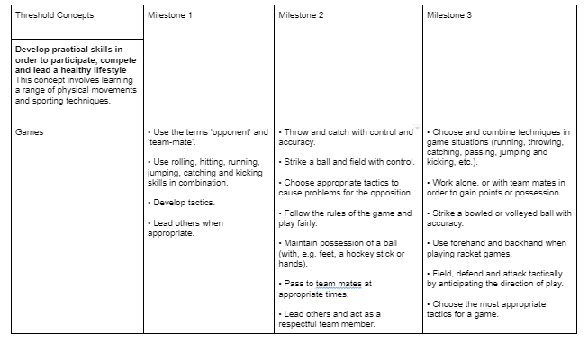

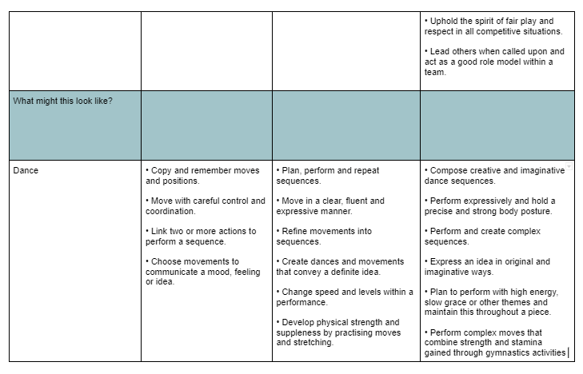

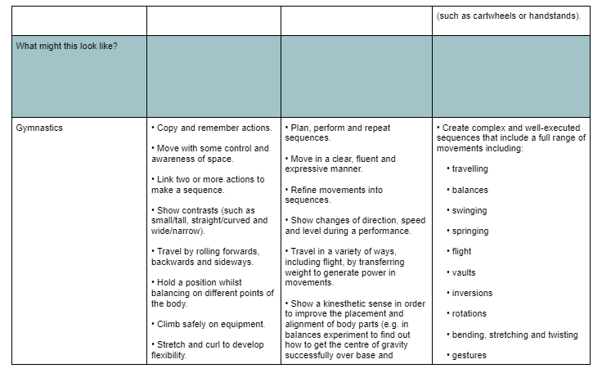

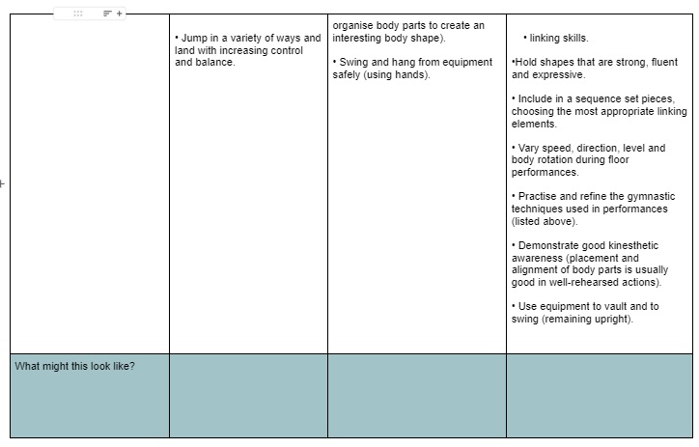

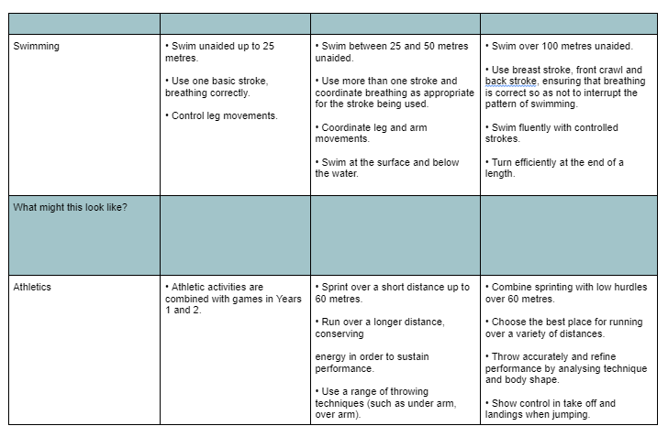

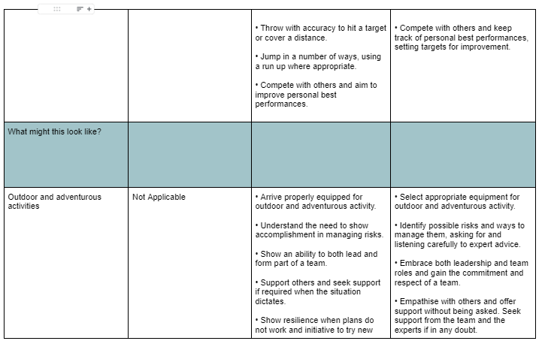

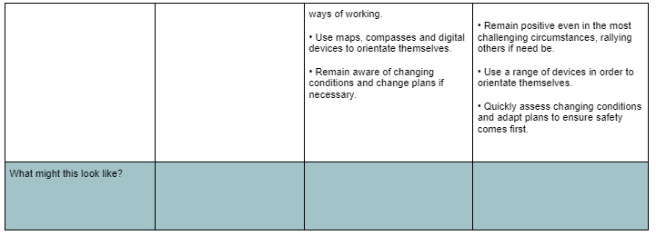

**Last Year’s Successes**

* Both schools have provided an after-school sports club each week throughout the term.
* Both schools swam for a 10 week period (years 3-6).
* Both schools have been taught the compulsory 2 hours of PE each week.
* Sports leaders (Y6) monitored games at break and lunch times and were responsible for equipment and huff and puff and completed sports leadership training.
* Germoe took part in a surf club throughout the summer term.
* Equipment for use of break times and PE lessons have been improved due to an audit check on the things the schools didn’t have.
* Received free resource packs which boosts our equipment and the opportunity for children to experience new and exciting sports.
* Olympic athlete visited schools to talk about their journey, which helped us raise funds for new equipment for both schools.
* Surf clubs and sailing clubs offered for both schools in summer term.
* Staff meeting on up-to-date PE framework delivered to the rest of the teachers.
* Worked closely with the head of PE in our cluster who came to both schools to deliver staff meetings and sports leadership training.
* Competed in football leagues for (years 3-6).
* Competed in the swimming gala for (years 5-6).
* Attended the yearly PE conference meeting.
* Created a ‘PE key vocabulary’ for each subject for teachers to use.
* Pe rota for both schools so classes didn’t clash on the playground or field.

**Priorities for this Year**

* An inter-school tournament between both schools.
* Increased participation in after-school sports clubs.
* Continued participation in inter-school competitions.
* ‘Pupils’ voices’ established as key components in our decision-making processes.
* Olympic athlete to visit both schools and talk about their journey.
* Children fundraise to buy more sports equipment for both schools.
* Make sure both schools have enough equipment to be able to teach all sports correctly,

accurately and to a high standard.

* To give children at both schools a summer surf club to attend.
* Questionnaires to staff about the overall subject of PE and what they would like to learn more about for their CPD.
* Engage with Youth Sport Trust.
* Termly audit of PE equipment so children have appropriate resources.
* Sports leader programme.
* Staff questionnaire on confidence and subject knowledge.
* Local specialists to come into school.
* Engage with Cornwall school games.
* Apply for Cornwall school games mark.
* Have a clear understanding of when PE is being taught across both schools and at what times.
* Give each teacher the chance to have some side-along coaching to share expertise.
* Following the new guidance: ‘Ahead of a huge summer of sport in 2024, schools will receive new guidance on delivering two hours of PE a week, and equal access to sport and PE.’ We will make sure children receive two hours of quality PE each week and we will make sure PE and Sport throughout both schools are inclusive and available for all children.