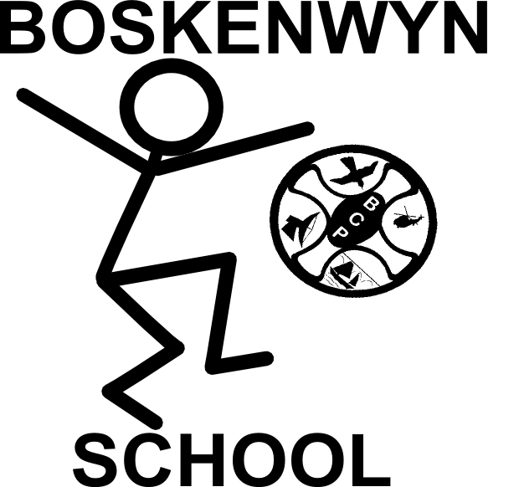
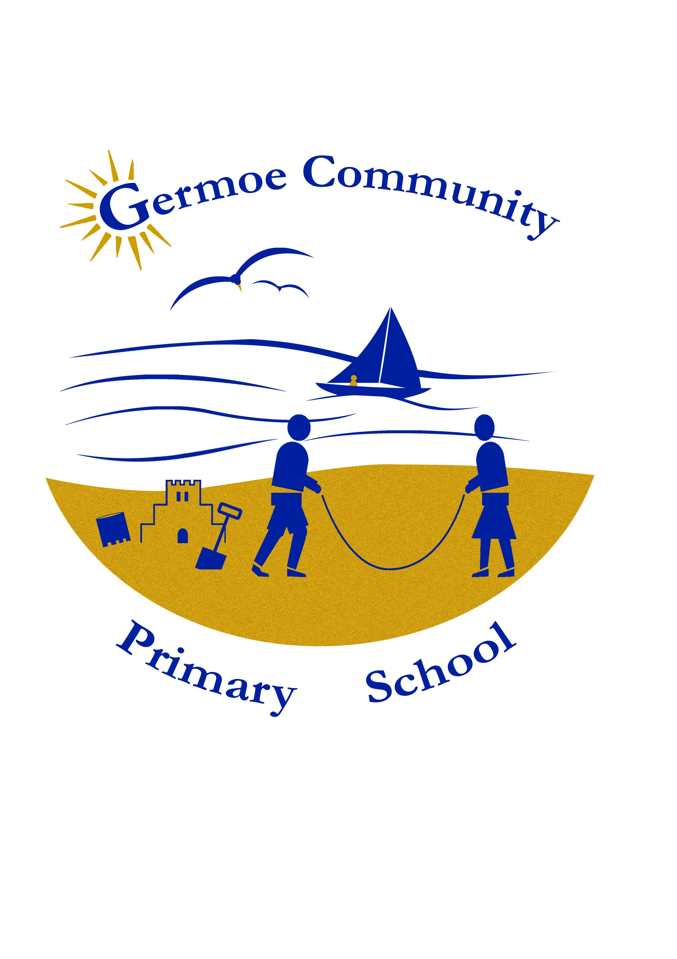

The Federation of Boskenwyn & Germoe Schools

Bereavement Support for Parents and Carers

The Federation of Boskenwyn and Germoe Schools have a Bereavement Policy to help us support children, families and the school community at times of loss.

At these very difficult times, it is sometimes difficult to know what to say and how to be with the bereaved, and others affected by the loss, or to cope with personal grief alongside the grief of others. This is particularly difficult if children are grieving too.

Here is some information and links to help. We will do all we can here at school, to support your child and your family, so please inform us of any loss.

Here are some supportive websites to help families:

www.penhaligonsfriends.org.uk

www.childbereavementuk.org
- Books for children
- Help Line 0800 02 888 40
- Live Chat via the website available 9am – 5pm Monday to Friday
- Help and advice for parents
https://www.penhaligonsfriends.org.uk/
- Support for children and young people
- Support for parents and carers
http://www.childhoodbereavementnetwork.org.uk/home.aspx

www.cruse.org.uk and www.hopeagain.org.uk

www.winstonswish.org
- Books to help children understand loss through story

Stories that help children to process loss:

Badgers Parting Gift , Susan Varley
The Memory Tree, Britta Teckenstrup
The Invisible String, Patrice Karst & Joanne Lew-Vriethoff
Tell me About Heaven, Grandpa Rabbit, Jenny Album
Grandad’s Island, Benji Davies
The Memory Box, Joanna Rowland and Thea Baker
Where are you?, Laura Oliveri
Till we Meet Again, Julie Muller and Camryn Cox

It is also important to remember:

‘Most grieving children do not need a ‘bereavement expert’ they need people who care.’
Child bereavement UK
‘Telling our story is how we process loss’
Becky Thomas, Penhaligon’s Friends



