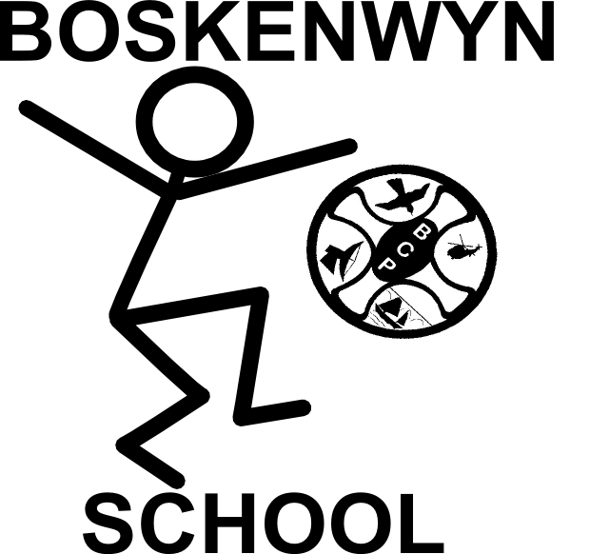


The Federation of Boskenwyn & Germoe Schools

11th February 2019
Boskenwyn Parent Governor Meeting

1. Traffic
- Parents are concerned that cars are speeding past the school
- Parents wondered if funds could be raised to get a speed camera
- It was suggested that the children could be involved in making something to take action
- Schools in Falmouth - children worked with the police using a speed gun to collect data
- Possibility of speed bumps (Parish Council)
ACTION: Children to do a traffic survey, posters, write to Parish Council etc

2. Playground Tidiness
- Parents noticed that there were a lot of pieces of equipment scattered on the playground when they arrived in the morning. Discussion about whether this was due to not tidying up or children after/before school getting materials out again. Suggestion to incorporate ‘tidy-up’ time at the end of play
ACTION: PB to speak to staff in next staff meeting regarding tidy up time

3. Bullying
- Question: Is bullying being properly tackled?
- Russ responded with explanation that a lot of work has been done regarding bullying: creating safe places, clear rules, children knowing who to talk to.
- Parents maybe not aware of this work - need to make it visible via newsletter/website etc.
- There seems to be different understandings of the term bullying - maybe need to clarify this
- Parents were concerned that they had noticed a bullying incident and had spoken to teacher but didn’t see any action. Paula explained that a lot of the time behavioural incidents are confidential and so they may not explicitly see the behaviour being dealt with. The term bullying is being used to describe an incident
ACTION: Anti-bullying workshop for parents, anti-bullying workshop for children, publication of behind the scenes actions and their impact

4. Questionnaire
- Paula explained the results of the questionnaire: Mainly positive, and parents invited to come and talk if they have concerns or queries
ACTION: when majority of questionnaires have arrived, PB will put the result on the website

5. Assemblies
- Parents suggested that a variety of faith groups are invited to talk at assemblies.
- Two parents offered to talk about Paganism - discussion about whether parental permission was needed for this
ACTION: PB to draw up a rota for parents to talk in assemblies about their jobs to raise aspirations. PB to discuss with staff at next staff meeting

6. Governor Who’s Who
- Suggestion that governing body is made visible to parents.
ACTION: Meet and greet/newsletter/notice board, PB to speak to Miss Reeves about school Newspaper

7. Learning Environment
- Parents noticed that a pile of old materials ready to be thrown away was still in situ.
- Parents offered to take materials to the tip on a regular basis.

8. Football Team
- Football team is starting up - parents very happy
ACTION: FC to complete D1 on driving licence so he can take children to sporting events

9. Dance and Singing
- Is there a possibility of more dance and singing after school?
- Could we offer guitar lessons? 4 children already want it
- Comment that ‘the specialist music teacher in Church Cove Class is working really well’
ACTION: PB put on newsletter for parents to express interest in guitar lessons, Wake and Shake to begin again with Mr Conway

10. Mini-bus
- Suggestion that the school minibus might be used to ferry children from Constantine rather than all parents bringing cars.
- Russ explained that we can’t pay a driver, it costs 50p per mile and you would need a mini-bus license.
- Questions: Could the insurance be changed on the bus so that it can be kept overnight somewhere else? What happens if it is needed for a trip during the day?

11. Classes for next year
- Paula explained the potential class set up for next year: R+Y1, Y2, Y3+Y4, Y5+Y6.

12. Payment methods
- Question: Is it possible to pay into a bank account rather than cash? Yes - need to share details with parents.
ACTION: Information shared on newsletter

