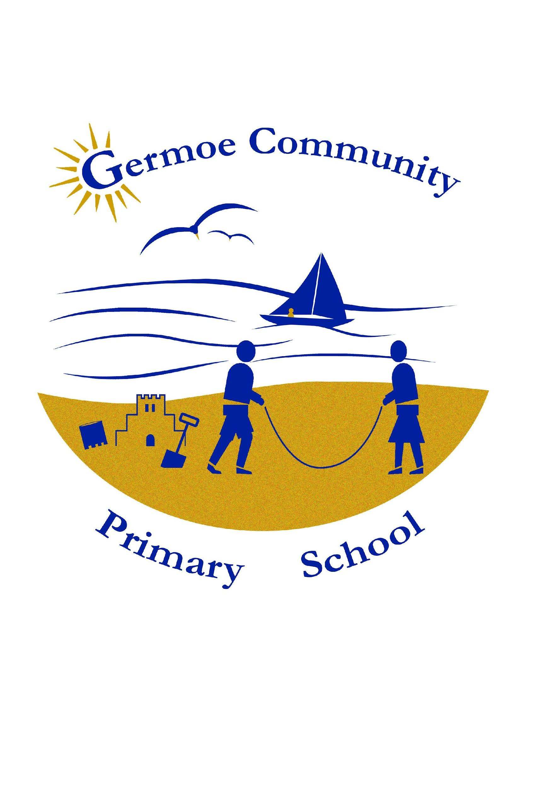

A Journey into Computing

|  |  |  |  |  |
| --- | --- | --- | --- | --- |
| Using Scratch to programme games |  | Using ScratchJr to code in Key Stage 1 |  | Using Google Earth to explore the world |

**Intent**

At Boskenwyn and Germoe Schools we want pupils to be MASTERS of technology and not slaves to it. Technology is everywhere and will play a pivotal part in students' lives. Therefore, we want to model and educate our pupils on how to use technology positively, responsibly and safely. We want our pupils to be creators not consumers and our broad curriculum encompassing computer science, information technology and digital literacy reflects this. We want our pupils to understand that there is always a choice with using technology and as a school we utilise technology (especially social media) to model positive use. We recognise that the best prevention for a lot of issues we currently see with technology/social media is through education.

We recognise that technology can allow pupils to share their learning in creative ways. We also understand the accessibility opportunities technology can provide for our pupils. Our knowledge rich curriculum must be balanced with the opportunity for pupils to apply their knowledge creatively which will in turn help our pupils become skilful computer scientists.

We encourage staff to try and embed computing across our inquiry curriculum to make learning creative and accessible. We want our pupils to be fluent with a range of tools to best express their understanding and hope, by Upper Key Stage 2, children have the independence and confidence to choose the best tool to fulfil the task and challenge set by teachers.

**Implementation**

We have created a comprehensive progression document for staff to follow to best embed and cover every element of the computing curriculum. The knowledge/skills build year on year to deepen and challenge our learners. Our progression document and curriculum is embedded alongside the Chris Quigley Essentials Curriculum and National Curriculum programmes of study for Computing to ensure our objectives align. We set our objectives using the four key Threshold Concepts:

* Code: This concept involves developing an understanding of instructions, logic and sequences.
* Connect: This concept involves developing an understanding of how to safely connect with others.
* Communicate: This concept involves using apps to communicate one’s ideas.
* Collect: This concept involves developing an understanding of databases and their uses.

At Boskenwyn and Germoe we feel that the majority of computing should be embedded across our Inquiry curriculum. Teachers will use **an explicit computer science** lesson or **a tinkering session** when needed, which allows teachers to implement our Inquiry curriculum. The computer science (code) part of the computing curriculum will usually, but not always, need a more explicit approach. A tinkering session looks at introducing a new app or tool and giving children the opportunity to experiment and familiarise themselves with the different elements and tools before it can be applied in a more focused approach across the curriculum.

**Impact**

We encourage our children to enjoy and value the curriculum we deliver. We will constantly ask the WHY behind their learning and not just the HOW. We want learners to discuss, reflect and appreciate the impact computing has on their learning, development and well-being.

Finding the right balance with technology is key to an effective education and a healthy lifestyle. We feel the way we implement computing helps children realise the need for the right balance and one they can continue to build on in their next stage of education and beyond. We encourage regular discussions between staff and pupils to best embed and understand this.

The way pupils display, share, celebrate and publish their work will best show the impact of our curriculum. We also look for evidence through reviewing pupil’s knowledge and skills digitally through tools like Google Drive and Seesaw and observing learning regularly.

Progress of our computing curriculum is demonstrated through outcomes and the record of coverage in the process of achieving these outcomes.

**Pupil Voice**

‘I love using Scratch because it is fun making my own games’.

‘I like using Seesaw to show what I have made and learned at school’.

‘Doodle is good to help me practise Maths, English and Spelling’.

**An Example Progression of Skills**

Milestone 1 (KS1) Milestone 2 (LKS2) Milestone 3 (UKS2)

|  |  |  |  |  |
| --- | --- | --- | --- | --- |
| **Code** This concept involves developing an understanding of instructions, logic and sequences. | Motion | • Control motion by specifying the number of steps to travel, direction and turn. | • Use specified screen coordinates to control movement. | • Set IF conditions for movements. Specify types of rotation giving the number of degrees. |
| Looks | • Add text strings, show and hide objects and change the features of an object. | • Set the appearance of objects and create sequences of changes. | • Change the position of objects between screen layers (send to back, bring to front). |
| Sound | • Select sounds and control when they are heard, their duration and volume. | • Create and edit sounds. Control when they are heard, their volume, duration and rests. | • Upload sounds from a file and edit them. Add effects such as fade in and out and control their implementation. |
| Draw | • Control when drawings appear and set the pen colour, size and shape. | • Control the shade of pens. | • Combine the use of pens with movement to create interesting effects. |
| Events | • Specify user inputs (such as clicks) to control events. | • Specify conditions to trigger events. | • Set events to control other events by ‘broadcasting’ information as a trigger. |
| Control | • Specify the nature of events (such as a single event or a loop). | • Use IF THEN conditions to control events or objects. | • Use IF THEN ELSE conditions to control events or objects. |
| Sensing | • Create conditions for actions by waiting for a user input (such as responses to questions like: What is your name?). | • Create conditions for actions by sensing proximity or by waiting for a user input (such as proximity to a specified colour or a line or responses to questions). | • Use a range of sensing tools (including proximity, user inputs, loudness and mouse position) to control events or actions. |
| Variables and lists | • From Year 3 onwards. | • Use variables to store a value.  • Use the functions define, set, change, show and hide to control the variables. | • Use lists to create a set of variables. |
| Operators | • From Year 3 onwards. | • Use the Reporter operators  () + ()  () - ()  () * ()  () / ()  to perform calculations. | • Use the Boolean operators  () < ()  () = ()  () > ()  ()and()  ()or()  Not()  to define conditions.  • Use the Reporter operators  () + ()  () - ()  () * ()  () / ()  to perform calculations.  Pick Random () to ()  Join () ()  Letter () of ()  Length of ()  () Mod () This reports the remainder  after a division calculation  Round ()  () of (). |

**Key Vocabulary**

**Curriculum**

Children of Boskenwyn and Germoe Schools engage with all areas of the Computing curriculum, within a scope that covers all milestones essential for progression.

Computer science – children learn fundamentally about algorithms from the early years all the way through to Year 6. They use different software to input algorithms and learn increasingly complex algorithms that they can input to devices as they progress through year groups. They increase their understanding of programming through the basic use of novice software involving coding and inputting algorithms. EYFS begin with access to iPads, playing interactive games on them and the interactive boards, through to KS1 where they use ScratchJr to input basic algorithms to complete sequences. KS2 transition from ScratchJr to the most up to date version of Scratch, creating more complex sequences using a wider range of algorithms to input. Data is taught within the KS2 Maths curriculum, learning to input and interpret data using Microsoft Excel, learning a wider range of ways to do so through the year groups.

Information technology – A wide variety of digital artefacts are created all the way through the schools and year groups. A range of Microsoft Office and Google software is used to present and document learning. Regarding digital art, Seesaw is used in KS1 and Procreate is used in KS2. Through our Inquiry, children are often given the choice of which software to use to document their learning, and are given appropriate options beforehand. All year groups learn to understand the use of technology for a range of purposes, and how to use it appropriately and safely through digital literacy sessions set out for both key stages across the year. During these lessons in KS2, the children learn about how to identify reliable sources and what to look out for when identifying a reliable source.

Digital literacy

Children start in KS1 by accessing a range of hardware, such as iBoards and iPads, as well as Chromebooks towards the end of KS1. In KS2, the children have access to all of these devices, while being able to develop their understanding of how to use each device effectively.

Memory

Children are given research opportunities in both Key Stages to develop automaticity and fluency in using devices. Practicing inquiry and research helps children understand various ways to find information, hence developing automaticity.

Early years

In the early years foundation stage, children are given the opportunity to play on iBoards and iPads, to build familiarity with the devices and how to access them. They also learn to access various software. This prepares them for KS1, in which they will be accessing these devices for inquiry, research sessions and computing.

**Pedagogy**

All computing activities are planned alongside the curriculum intent and essentials curriculum outlined. This allows the approaches of retrieval and teaching of digital literacy, computer science and information technology to take place within each milestone to develop prior knowledge. All computing ad inquiry lessons are planned alongside the essentials curriculum and intent to ensure that all lessons involving Computing are engaging and focused primarily on developing computing skills to aid learning. The children in both Key Stages are encouraged to research independently, focusing on the methods and skills taught to solve any difficulties they encounter in the research process.

**Assessment**

Formative assessment is used throughout lessons involving Computing, focusing on research methods, digital literacy skills and a range of ways to present learning and obtain new knowledge. Various pieces of work are displayed on Seesaw and on Scratch accounts for coding. A conscious formative assessment approach to Computing allows the focus to be on the methods and skills required to research effectively, which allows the children to enhance these skills and develop their understanding of using them efficiently.

**Culture**

At Boskenwyn and Germoe Schools, the approach to Computing is holistic across the curriculum, as we strive for all children to be masters of technology and not slaves to it. These confirms a strong belief that technology should be accessible to all, and used to develop understanding of the world. Various trips to develop technological understanding are embedded across our curriculum, such as the telegraph museum, the Eden Project, the maritime museum, and tin mines.

**Systems**

The subject leader for Computing has been developing their competence in Computing and has undertaken training to do so. They are continuing to undertake training for both subject leadership and teaching Computing. All members of staff across both schools are well supported and are offered advice and resources for teaching Computing if it is needed. In future, the Computing subject lead will be leading an INSET session to allow all members of staff to practice using a wide range of software to further embed Computing across the curriculum. All classes contain the necessary devices to develop their areas of the Computing curriculum. When are there not enough devices in one classroom, devices are shared across classrooms to ensure there are a suitable amount of devices accessible to all children. The subject lead is continuously seeking additional devices to purchase for use across both schools.

**Policy**

Embedding Computing within the Inquiry-based approach and across the whole school curriculum allows for sufficient time to be allocated to Computing, with it being a focus across a range of subjects and lessons. This also asserts the whole school understanding that Computing must be taught across all areas of the curriculum in the early years and both Key Stages.

**Examples of Learning Outcomes**

**Our Learner Profiles**

The learner profiles that we follow underpin our Inquiry curriculum and the skills that we aspire for the children to master. Here is an overview of the learner profiles that we follow and learn:

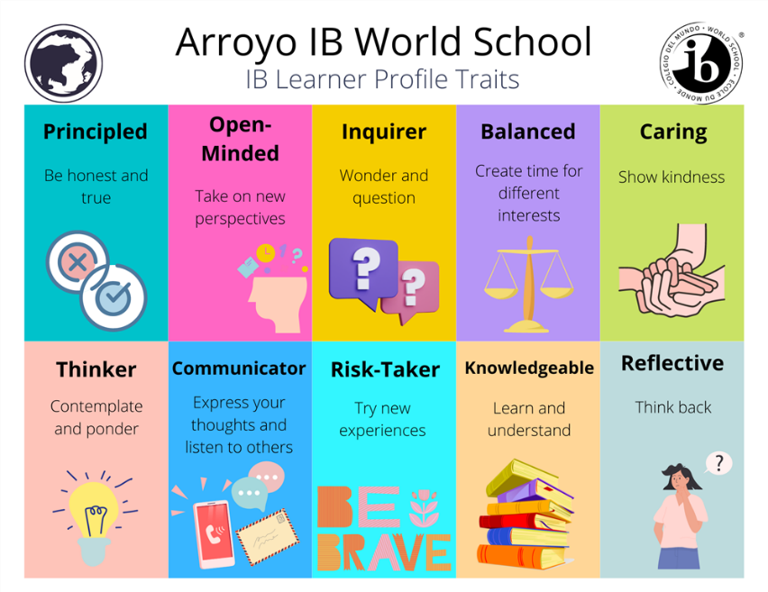

Here are a few examples for how the learner profiles apply to Computing:

Risk-Taker: When accessing new software, being given time to become familiar with the software and what they can teach themselves. When coding, trying a variety of inputs to see what you can instruct a sprite to do. When presenting learning through research and inquiry, exploring a variety of websites to gain and retain information, as well as using new and innovative software to present learning.

Communicator: When presenting learning through research and inquiry, exploring a variety of websites to gain and retain information, as well as using new and innovative software to present learning. Using a range of tools such as presentations, voice notes, videos or typed examples of work to present learning.

Inquirer: Using iPads, laptops and iBoards to find out the answer to big and small questions within inquiry, and using the information that they manage to access to present what they have read from websites and what they have learned.

**Cultural Capital**

Cultural capital is about preparing pupils with the essential knowledge and skills for what comes next. The exploration of new skills and experiences helps to nurture resilience, curiosity and creativity. Through this journey pupils develop new forms of cultural capital that makes a difference in individual mind-sets, which consequently shapes their future.

Cultural capital is the accumulation of knowledge, behaviours, and skills that a child can draw upon and which demonstrates their cultural awareness, knowledge and competence; it is one of the key ingredients a child will draw upon to be successful in society, their career and the world of work.

Cultural capital promotes social mobility and success.

Cultural capital gives a child power. It helps them achieve goals, become successful, and rise the social ladder without necessarily having wealth or financial capital.

Cultural capital is having assets that give children the desire to aspire and achieve social mobility whatever their starting point.

Ofsted defines Cultural Capital as:

*‘...the essential knowledge that pupils need to be educated citizens, introducing them to the best that has been thought, said, and helping to engender an appreciation of human creativity and achievement.’* Ofsted School Inspection Handbook 2019

Cultural capital can be achieved through computing in various ways in our curriculum alone. In a society becoming increasingly reliant on and fluent with technology, understanding how technology is coded and used is an increasingly essential skill to understand to contribute to wider society. Exposing children to different types of technology allows all children to understand technology and use it to their advantage. Children can understand how to inquire using technology and become creative with this as their fluency with different forms of technology increases.

Examples of cultural capital in computing at Boskenwyn and Germoe schools:

* Engagement in Back to the Future Erasmus project: Learning about what the future holds and how technology will be used in the future
* Engagement in Carousel of True Friendship: Exposure to different software, broadening understanding of software use, working collaboratively to use technology effectively
* Range of technology in schools: Opportunities to use a range of hardware allows us to address the social inequality that only allows some children to access technology – it widens pupils’ opportunities.
* WhatsApp pals - Children of year 6 developed friendships with international partners and shared traditions and values, exposing them to cultural similarities and differences, and using technology to engage with different social and cultural groups.

**Our Multi-Disciplinary Approach**

Our Federation’s topic-based inquiry approach provides opportunities to research and inquire using a range of resources and experiences. Pupils are enabled to apply their knowledge of computing into different settings and subjects. A full range of learning styles is offered, and computing is incorporated into a wide range of subjects. Children can use what they have learnt in computing sessions to display their learning in other subjects.

**Previous Year’s Successes (2022-23)**

* Merge staff Google accounts with Microsoft Office 365
* Purchase of microbits for KS2
* Setting up KS2 Scratch accounts and classes for all 4 KS2 classes
* Lessons led for use of microbits by provider for KS2 classes
* Subject lead and class teacher attended Digital Turn KS1 and KS2 Computing training in Tenerife (January 2023)
* Computing INSET session for staff across both schools completed
* Subject lead attended digitalisation training in Estonia (March 2023)
* Staff beginning to familiarise with Microsoft Office software

**Last Year’s Successes (2023-24)**

* Micro:bit kits ordered for both schools through the BBC
* Staff continuing to familiarise with Microsoft Office software
* Introduction of ChatGPT to aid staff with lesson plans, activities, reports, providing texts and for inquiry use
* New Chromebooks for Year 5/6 at both schools
* Older Chromebooks distributed through Year 3&4 and Year 2 classrooms to enhance resources
* Subject leader attended AI in Education seminar to learn to implement AI tools in the classroom and for support with planning lessons

**This Year’s Successes (2024-25)**

* New progression of vocabulary document for Computing from EYFS to Year 6
* New Computing curriculum written alongside Essentials curriculum

**Priorities**

* Lead a Seesaw workshop for parents
* Continue to look out for grants and resources to enhance Computing equipment and training
* Staff to continue to familiarise with Microsoft Office software
* LEGO Engineers club to enhance computer science understanding for LKS2 children (Boskenwyn)