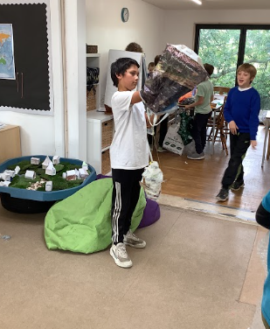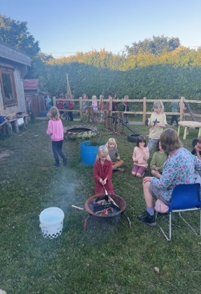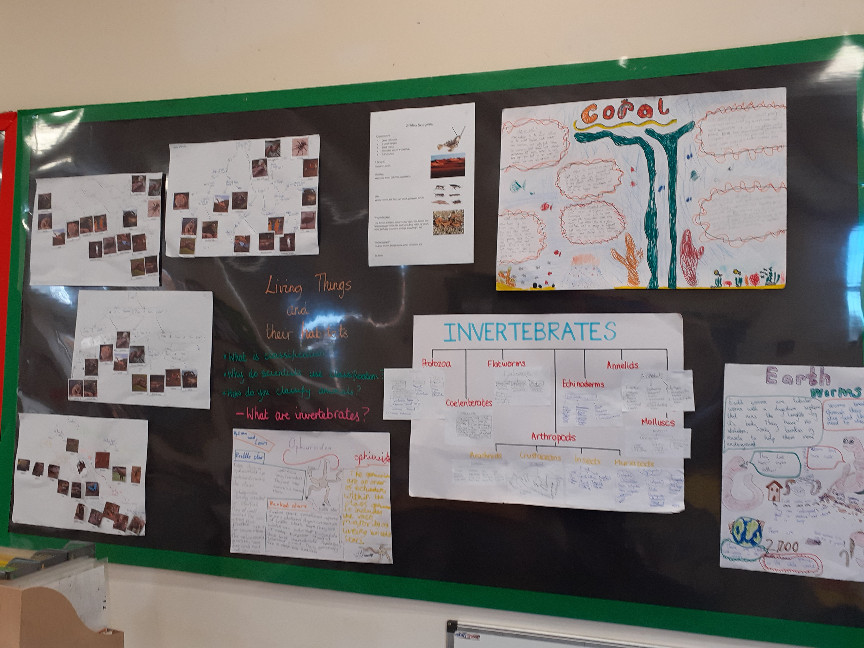
Intent
Our Inquiry based, child-led topics, allow, where possible, for context relevant learning, giving purposeful meaning and real-life relevance to scientific learning. Our aim is to make the interconnectedness of our world explicit, and science concepts less abstract, to build a web of understanding about the world which creates a sense of awe and wonder.
We aim to create free thinking and promote an inquisitive approach to our world through science, encouraging children to pose their own questions and enquiries. ‘I wonder …?’ and ‘What if …?’ statements promote independence of thought and deeper engagement with the concepts being learnt, skills being applied and independence in working, at a much more personal level. All learners are able to access scientific learning at a level and in a way that is appropriate for them, and highlights no sense of difference to others in the class, as all may be following slightly different inquiries. Problem based learning within an Inquiry approach promotes ‘ownership’ of the learning process, which is empowering for our young scientists.
‘The best way for students to learn science is to experience problems that challenge science, and the thought, habits of mind and actions associated with trying to solve them. This implies opportunities for authentic, inquiry-based learning. Problem-based learning is a powerful vehicle for this, in which a real-world problem becomes a context for students to investigate, in depth, what they need to know and want to know (Checkly, 1997). It is a robust, constructivist process, shaped and directed primarily by the student, with the instructor as metacognitive coach.’
Nina Greenwald (2001)
The whole school ethos of learning which is based on ‘Building Learning power’ and ‘Growth Mindset’ thinking, has given permission to children to have a go, make mistakes and try again. There may be no right or wrong answer, but the process is where the learning is.
Science is an exciting subject that links to all other areas of learning when a creative approach is taken. The multi-disciplinary approach engendered by Inquiry, draws on integrating different areas of learning that cross the boundaries of individual disciplines to enhance the scope and depth of learning. It can excite, inspire, and raise aspiration in our children of the possibilities open to them and allows growth in our children’s cultural capital.

Implementation
Throughout the school, ‘working scientifically’ skills are explicitly taught and modelled. Discussion, debate and analysis allow thinking and application to develop sequentially and cumulatively to give the learners a firm foundation for future scientific learning and life beyond school.

Scientific content is interwoven with termly topics which ensures children will encounter the concepts in a multi-disciplinary way, and learning will be more relevant and part of a richer foundation of knowledge and skills, than would otherwise be the case. This also permits different ways of viewing, which has been promoted by Reggio Emelia ideas that our schools have focused on. Our Inquiry based learning allows learners to integrate new knowledge into larger concepts over time, so the foundation of their learning is strong and adaptable.
Hands on and practical learning is a key-stone of classroom practice, as is collaborative working. Use of ICT for modelling, provocations and stimuli, problem based, experiential learning, enrichment, trips and visits, and use of the local environment enhance our scientific diet. The impact of this kind of learning embeds more readily, and children often talk about experiences from years before, which shows the impact achieved by this approach to learning.
Children’s skill base, scientific application and thinking, are assessed to identify areas of strength and weakness. Support is offered through comments in books, conversations during learning time and questioning that allows scaffolded thought, learning and progression. Collaborative working also supports skill development and encourages scientific discussion relating to the working scientifically objectives.
Children with additional needs are encouraged to explore their ideas with support, and presentation of their learning, as with all children, may not be written. Whilst written recording is important, it is also important that this does not hamper them in their engagement or enjoyment or prevent them showing and sharing their scientific learning and understanding in a way that is meaningful to them.
Teachers focus on high quality teaching for all, making learning as multi-sensory as possible, working with the ‘Five a Day’ principle for all children, and using Retrieval practice to enhance recall, embed neural pathways and develop application.
Science at Boskenwyn and Germoe may look different in each class, but the common characteristics will be discussion, questioning, problem posing and solving, collaborative working, debate, sharing skills and presentation, trial and error, modelling and explanation, linking to previous learning and to different areas of experience. And of course, practical and proactive engagement. Our science is experiential, and from the play-based discovery learning and schemas in Early years through to the more structured investigative approach in Y6, the characteristics of good learning remain the same.
Impact
Science is very much enjoyed in school. Children have commented that they prefer a particular content focus over others, which is quite natural – most of us would have a preference for either biology, chemistry or physics, but our curriculum allows for flexibility of approach and the inquiry topic-base opens up opportunity for children to perhaps investigate friction through animals or material properties through a textile focus, art based focus or through plate tectonics or volcanoes ; biology through ecological or environmental avenues.
Each year the science grants are applied for, and children fondly remember and comment on previous science weeks, such as ‘Crime Scene investigation’ and ‘Body Week’. Trips and visits also impact on the children’s emotional engagement with science - Falmouth Maritime Museum and the Telegraph Museum have widened the children’s awareness of scientific technological advancement in their own County and the world-wide implications this has had. Visits to the ‘Marine Biologist for a Day’ with Plymouth Marine aquarium, encourage children to think about future pathways in learning and life they may like to follow.
Enrichment for science is embedded in school with ever-growing links between science, other disciplines and cultures. Green car competitions, skiing trips, sailing, gardening and cookery clubs to name a few, have helped to promote science in school and as a fun, useful and engaging area of learning, in its many forms.
Success in science is measured against objectives set out at the beginning of the half term, taken from the National Curriculum, chosen to link learning that relates to the big picture but also allows focus on finer detail and specific skills. Much of the children’s learning is related to process as much as outcome and their subsequent use and application of their learning.
‘It is through try outs, testing, and further information search that individuals begin to see patters or connections, often leading to discoveries.’
Faculty of Education, Mara, Malaysia, 2013
‘…. the importance of competencies enhanced through Inquiry Based Science Education are decision making, critical thinking, adaptability, tolerance and autonomy.’
Aksela et al. (2010)
The children’s journeys are documented with written work, text, visual or sound recording or mixed digital media, presentation, discussion and debate, exhibitions and displays, through art, modelling, and sharing with others. Individual work, collaborations and floor books and wall journeys also capture learning. Talking about your learning and the process of learning has also become more dominant in our classrooms, and the way we ask questions has supported metacognition and the development of deeper and more challenging lines of inquiry. Children’s enjoyment of their learning is an important indicator of the success of their learning.
The impact of our Inquiry based approach has been positive for our staff, with regular discussions about children’s learning, concepts and links, and the sharing of experiences and ideas. This has supported an up-beat, can do attitude within our staff, and a deeper connection has formed between all ages and stages within the school, where progression is more clearly understood and developmental needs relating to specific areas of study have become more deeply understood, especially in relation to skill development.
Pupil Voice
Children enjoy talking about their learning and conversations can be sparked randomly about areas of learning and us as learners.
‘I like learning new things… with science you remember things. If you do things, you remember it.’ Y6
‘I like doing experiments … it’s kind of like a mystery, finding things out …’ Y5
An Example Progression of Skills
EYFS | Y1/2 | Y3/4 | Y5/6
Look closely at similarities, differences, patterns and change | Observe closely, using simple equipment | Make systematic and careful observations and, where appropriate, take accurate measurements using standard units, using a range of equipment, including thermometers and data loggers | Take measurements, using a range of scientific equipment, with increasing accuracy and precision, taking repeat readings when appropriate.
 | Ask simple questions and recognised that they can be answered in different ways  Perform simple tests | Ask relevant questions and use different types of scientific enquiries to answer them.  Set up simple practical enquiries, comparative and fair tests | Plan different types of scientific enquiries to answer questions, including recognising and controlling variables where necessary

Progression of skills in science reflects the Inquiry based ethos – working toward independence in thought and action. In scientific learning, children have an innate desire to explore, investigate, test and experiment and we strive to support these natural curiosities though experiential, structured, controlled, guided and open enquiry, developmentally supportive for all ages and needs, but ultimately toward, independence and self-direction. Experiential learning is important to our ethos for all ages, along with collaborative learning and adult as facilitator, to scaffold thinking, challenge and extend.
For further information, please look at our ‘Progressive Skills Curriculum Science’ document.

Examples of Learning Outcomes
EYFS
Year 1 and 2
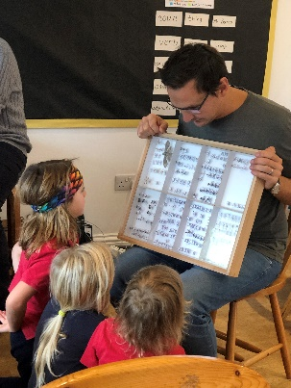
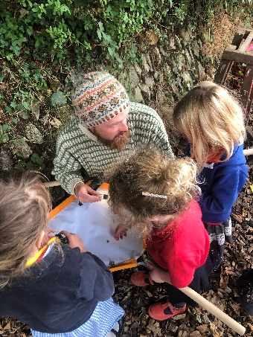
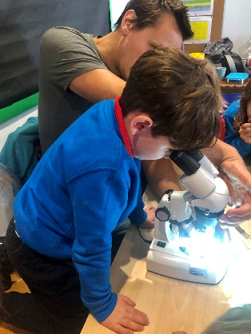
Inspired by University professionals
Learning about scientific collections
Expert instruction on
how to use a microscope

Year 3 and 4
Year 5 and 6
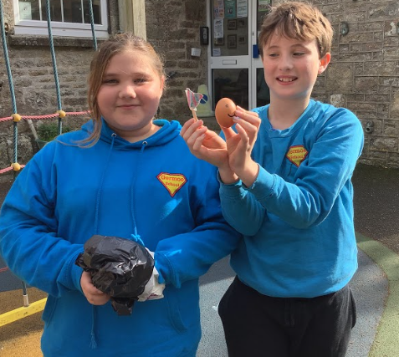
Two Year 5 children used their new knowledge of air resistance and gravity to successfully design and create their own parachute to protect an egg when dropped from a 7ft height. Their grins speak for themselves!

Our FAMILY Values
Our family values are embedded in our science curriculum, through connections with the environment, connection with others in the world, the interconnectedness of all things and human aspiration and endeavour as part of this. Our Family Values are also reflected in our perceptions of ourselves as scientists, ourselves as learners, our health, heritage, safety, economic and future developments, to name but a few links. Our topic based, multi-disciplinary approach to learning supports and enhances children’s exploration and sense of journey through science as citizens of the the world, with shared understanding and responsibility.

Cultural Capital
‘It is the essential knowledge that pupils need to be educated citizens, introducing them to the best that has been thought and said and helping to engender an appreciation of human creativity and achievement.’
Ofsted School Inspection Handbook 2019

The Federation of Boskenwyn and Germoe school seeks to offer children authentic, real world experiences that help them to feel emotional connection, understand the interconnectedness of people and our world, philosophies, discoveries and collaboration in human endeavour and achievement. The cultural capital our children are gaining is supporting their development as world citizens who have tolerance and understanding of others, different view-points and ways of thinking, being, and doing. Learners whose application, interaction and sharing, is preparing them to be world citizens whose working lives will be international, technological and socially responsible, whilst appreciating their own important cultural roots and belonging. Science is an important conduit to development of this:
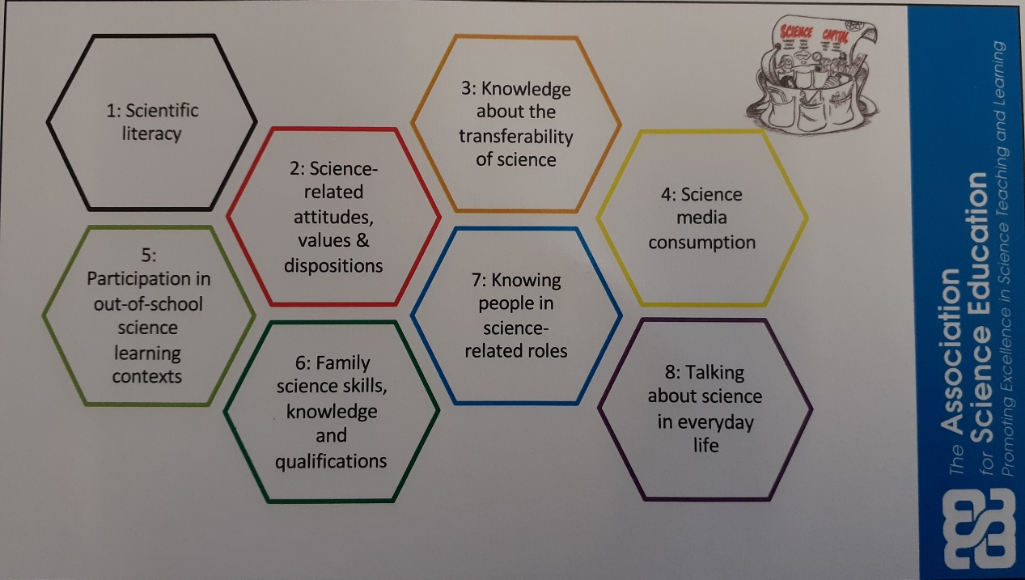

Our Multi-Disciplinary Approach
Our inquiry based learning, focused on metacognition, which gives ownership to the children to be creative and initiate pathways for their own learning and development, is readily supported by the multi-disciplinary approach. Areas of learning, knowledge and application are more integrated and relevant, and encourage learners to think for themselves, use, develop, and adapt prior learning, encouraging far more free and open thinking in our children, whilst developing key skills. This approach also develops awe and wonder in the world, humanity and processes which adds further dimensions of understanding. For example, materials have been taught through a focus on Ancient technologies, gases were explored through making a Roman hypocaust; and material properties through making an Archimedes’ screw, and a water clock, and sun-dials have also been made to explore ancient knowledge and understanding of the Earth’s orbit, as well as how scientific ‘truth’ has changed. In this way, children gain an understanding of progression and development of ideas and that scientific concepts can be dynamic and changing.
Our learning in science is often shown in different ways, which allows application of skills from other disciplines and areas of study to be practiced and shown, eg making dioramas for scientific concepts also includes art and design. In this way, skills and application are reinforced and children see how their learning can enable them to interact more widely and deeply with concepts – there are always a variety of different ways to go, and a variety of links to make, all of which make learning meaningful and relevant to an individual’s way of thinking and exploring.
Children with additional needs are well supported by the multi-disciplinary approach – their interaction, thinking and processing are all supported by the more open curriculum where there aren’t necessarily right and wrong answers, but a range of different possibilities and ways of presenting your learning. Engagement is good.
Last Year’s Successes
- Applied for a grant for STEM week in March – Germoe held a materials based week in Y1/2
- All classes now being taught science weekly rather than in blocks to enable easier retrieval.

Priorities for this Year
Apply for Science Grant for March STEM week
Apply for Learning in the Landscape grants to support contextual application of STEM learning
Establish science leadership file to support staff – vocabulary, milestones, progression documentation

