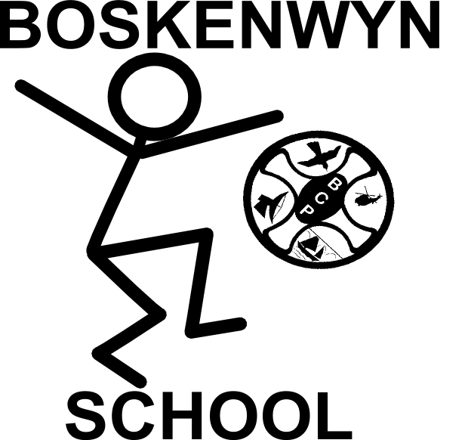
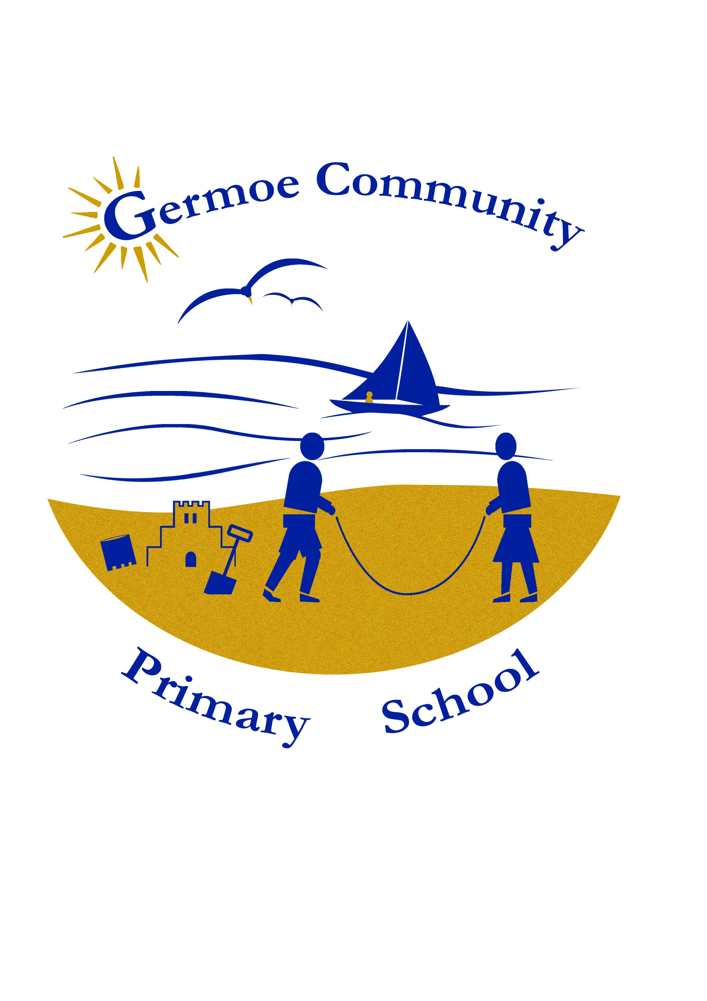

The Federation of Boskenwyn & Germoe Schools

Parent/governor meeting 12/3/18 Boskenwyn

Present: 12 parents (including 2 governors), P Quinney

Discussed recent professional development for staff to Finland. Parents asked what we learnt in Finland and what we would implement at Boskenwyn and Germoe. I explained the system of formal teaching at age 7 (year 2) entailed accelerated learning of reading, writing and maths. Preschool was attended full time by 97% of children and opportunities for learning were provided by the teacher. Most children went into school knowing how to read and write to varying degrees and some didn’t. We also had a discussion about sight vocabulary versus phonics. One parent stated that as our language is not phonetically friendly, it makes sense to learn sight vocabulary. I shared spelling data with parents and most agreed that sight vocabulary would help improve spelling as well as reading (without decoding) and agreed to support their children with high frequency flash cards.

Following on from a previous discussion with parents, we discussed rewards and their uses. Two parents suggested that rewards didn’t promote intrinsic motivation. I talked about my own experiences

Structure for 2018 – PAN. A parent asked about the set up for next year in terms of years groups. The planned structure was explained and the published admissions number for each year group. (6 preschool, 12 YR-Y3, 15 Y4-6). There will be 3.5 classes for September 18; PS/R/1 full time, Y5/6 full time and a Y2 plus a Y3/4 for mornings and a mixed Y2/3/4 for afternoons. Discussed what the school would look like at full capacity of 99 (93 school, 6 pre school).

Secondary school – parents discussed the International Baccalaureate at Truro-Penwith College with PQ, we feel that a secondary MYP (Middle Years Programme from the IBO is missing in our area.

Meeting closed 10.05 am

