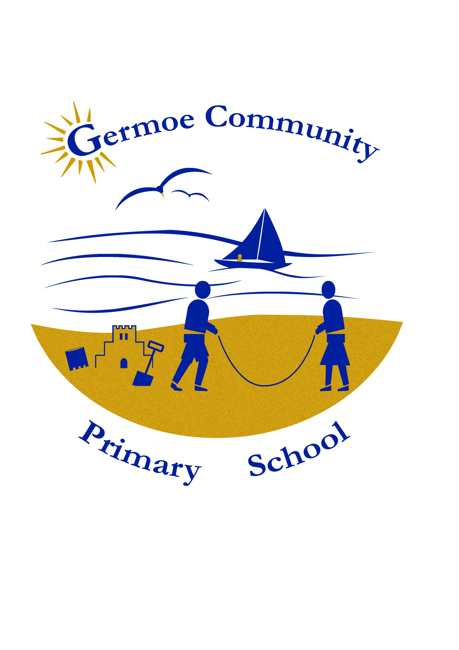
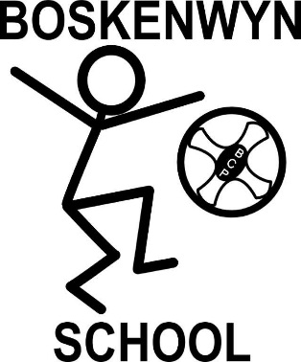
THE FEDERATION OF BOSKENWYN & GERMOE COMMUNITY PRIMARY SCHOOLS

BOSKENWYN COMMUNITY PRIMARY SCHOOL
Boskenwyn Helston Cornwall TR13 0NG Telephone (01326) 572618
Email secretary@boskenwyn.cornwall.sch.uk www.boskenwyn.cornwall.sch.uk

GERMOE COMMUNITY PRIMARY SCHOOL
Germoe Lane Germoe Cornwall TR20 9QY Telephone (01736) 763310
Email secretary@germoe.cornwall.sch.uk www.germoe.cornwall.sch.uk

Executive Head Teacher: Miss Paula Blackburn

A love of learning for life

12th March 2019
Dear parent/carer,

Re: Coronavirus concerns

You are likely aware of the outbreak of COVID-19 (coronavirus) and the subsequent confirmed cases in the UK and that it was yesterday declared as a pandemic. We take the health and safety of our pupils and staff very seriously, so we’re sharing guidance from Public Health England on steps you should be taking below. There’s currently no cause for concern at our schools, we receive daily updates from the DFE and Public Health England and monitor the situation closely. We will keep you informed about any developments and ensure we’re keeping the school as clean as possible to prevent the spread of any virus.

LATEST GUIDANCE:
Prevent the spread of infection
Make sure you and your children follow these general principles to prevent spreading any respiratory virus:
- Wash your hands often – with soap and water for at least 20 seconds, or an alcohol-based sanitiser if soap and water aren’t available
- Avoid touching your eyes, nose, and mouth with unwashed hands
- Avoid close contact with people who are sick
- If you feel unwell, stay at home and don’t attend work or school
- Cover your cough or sneeze with a tissue, then throw the tissue in a bin
- Clean and disinfect frequently touched objects and surfaces in the home

If you or your children have returned from a category 1 country or area in past 14 days
This includes:
Wuhan city and Hubei province, China
Iran*
Daegu or Cheongdo, South Korea*
Any Italian town under containment measures*
*Only if you’ve returned on or after 19 February 2020
Contact NHS 111 for advice, and:
Self-isolate for 14 days after leaving the country or area (see the home isolation advice sheet for help with this) and inform school immediately.
If you become unwell, call NHS 111 immediately for an assessment (or 999 if you require emergency medical attention) – see below for the symptoms to look out for

If you or your children have returned from a category 2 country or area in last 14 days
This includes:
Cambodia
China (other than Wuhan city or Hubei province)
Hong Kong
Italy: north*
Japan
Laos
Macau
Malaysia
Myanmar
Singapore
South Korea (other than Daegu or Cheongdo)
Taiwan
Thailand
Vietnam
*Only if you’ve returned on or after 19 February 2020
If you or your children are well, you don’t need to avoid contact with other people and your other family members don’t need to take any precautions or make any changes to their own activities.

If you become unwell (see below for a list of symptoms), stay indoors and avoid contact with other people as you would with other flu viruses (see the home isolation advice sheet for help with this).
Call NHS 111 immediately for an assessment (or 999 if you require emergency medical attention) and inform school immediately.
Symptoms to look out for
If you’ve returned from any of the category 1 or 2 areas or countries, look out for the following symptoms:
- Cough
- Difficulty in breathing
- Fever (a temperature of 38 degrees C or higher)
According to other official guidance, while you wait for further advice:
- Avoid contact with others
- Stay at home – don’t go to work or school – inform school of the situation
- Don’t travel while sick
- Cover your mouth and nose with a tissue or your sleeve (not your hands) when coughing or sneezing, throwing tissues in the bin
- Wash your hands often with soap and water for at least 20 seconds (or an alcohol-based sanitiser if soap and water aren’t available)

We are taking extra precautions in school, such as talking to the children about hygiene daily, washing hands to “Happy birthday” on entry, at break times and lunch times. Should a coronavirus case be identified from within our staff or pupils, we will seek immediate advice from Public Health England and inform you immediately with regard to the next steps. If you have any concerns or questions, please contact me on head@germoe.cornwall.sch.uk.

Yours sincerely

Paula Blackburn
Executive Headteacher
The Federation of Boskenwyn & Germoe Schools

